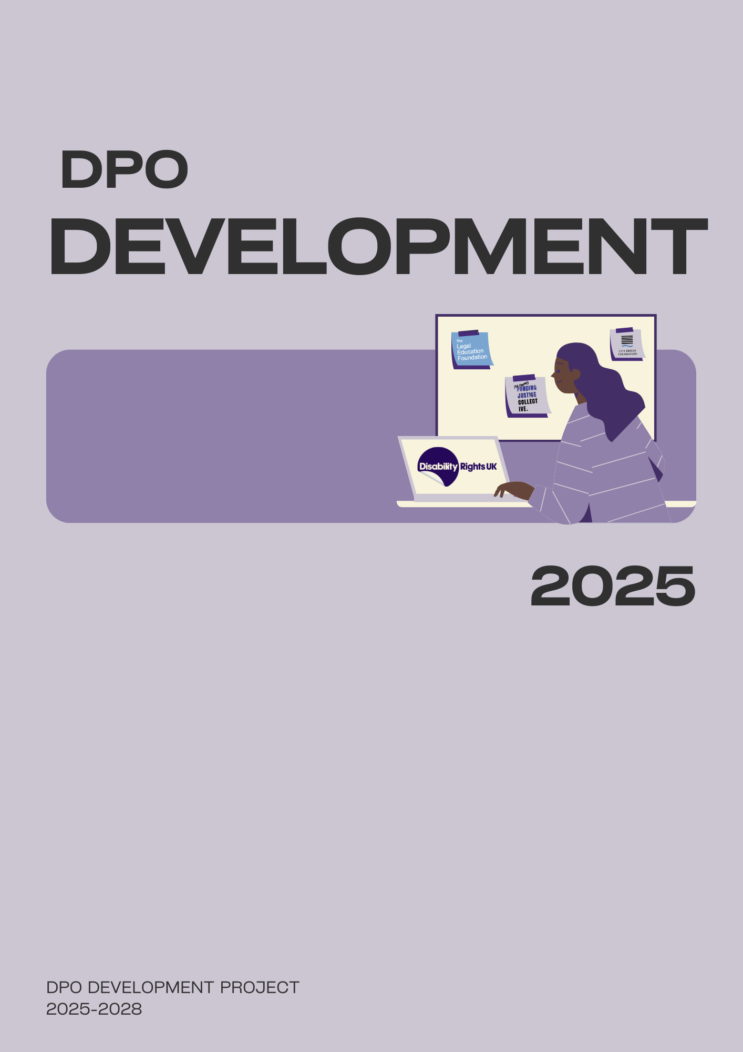


1
📌 Top Tips for Reading This Document 3
🔍 What’s This All About? 4
The Government’s stated Aims: 4
A real Consultation? 4
🚨 First things first, what’s NOT Being Consulted On? 5
1. Scrapping the Work Capability Assessment (WCA) 5
2. A new "Health Element" based on PIP assessments (not your ability to work). 5
3. PIP Daily Living Component Changes (From Nov 2026) 6
3. Universal Credit Health Element Freeze (2026–2030) 6
4. More Face-to-Face Assessments & Reassessments 7
📢 What IS Being Consulted On? 7
"Premium" for "Most Severe" Conditions 7
Time-Limited "New Out of Work Benefit" 7
Support for people who lose PIP 7
Raising Age Limits 7
Other features being consulted on: 8
💡What are some of the Impacts? 9
💡 Key Messages 9
⏰Parliamentary Timetable 10
⏰ Timetable of Cuts (Implementation) 10
✊ What Can You Do? 11
📖 Glossary 12
In-depth Insights 12
PIP Daily Living Component Changes Scoring 12
Other impacts of PIP Reform 12

Information Document: Pathways to Work Green Paper (2025)
For DPOs

📌 Top Tips for Reading This Document
- Glossary at the back explains jargon like "conditionality" or "passporting benefits."
- "Insider Notes" highlight what the government isn’t telling you.
- Key impacts are in bold—skip to these if short on time.

🔍 What’s This All About?
The government’s "Pathways to Work" Green Paper (published 18 March 2025) proposes major changes to benefits like PIP, Universal Credit, and ESA. They claim it’s about "helping people into work," but 90% of the reforms are cuts—and many aren’t even open for consultation!
📅 Extended Deadline for Consultation Responses: Responses due 30 June 2025 (initially 12 weeks, but accessible versions were delayed).

The Government’s stated Aims:
The UK Government released this green paper because they claim to want to:
- Stop people from falling into long-term economic inactivity through early intervention and support
- Deliver better and more tailored employment support to get more people off benefits, into work, and with a higher expectation to engage with that support
- Ensure the benefits system is financially sustainable to keep providing for those “who need it most”
- Protect and support Disabled people who won’t ever be able to work"

A real Consultation?
- The Green Paper is a sham consultation.
- While there are 22 major cost-cutting reforms proposed, only 12 are open to consultation.

🚨 First things first, what’s NOT Being Consulted On?
(These changes are happening, but the government won’t ask your opinion.)

1. Scrapping the Work Capability Assessment (WCA)
- Why it matters: The Work Capability Assessment decides if you must look for work or get extra money (£423/month) if you can’t work.
  - It aims to find out what work-related conditions you must meet to keep getting benefit.
  - If you are found to have a ‘limited capability for work’ in the assessment, your work-related conditions will be limited, with no job search conditionality (see glossary)
  - If you have a ‘limited capability for work-related activity’ in the assessment, none of the work-related conditions will apply to you, and you will also be entitled to the additional work capability amount (£423.27 per month).
- What’s replacing it? A new "Health Element" based on PIP assessments (not your ability to work).
- Insider Note: This removes protections from work requirements. More people will be forced to job-hunt.

2. A new "Health Element" based on PIP assessments (not your ability to work).
- Instead of the WCA, there would be a new system where your eligibility for any extra financial support for health conditions – a Health Element’.
- This new single assessment will replace:
  - PIP,
  - ESA
  - UC health
- This will be based on a revised PIP assessment, which considers your disability or health condition in daily living
- This does not cover your capacity to work.
- This would remove the right and protection of no work conditionality, which the WCA can provide.
  - Instead, it would be a system that encourages disabled claimants to look for and apply for jobs.

3. PIP Daily Living Component Changes (From Nov 2026)
- New rule: after Nov 2026, you’ll need 4 points in ONE activity (e.g., washing, dressing) plus 8 points total to qualify.
- Who loses out?
  - 87% of standard PIP claimants (1.1 million people) score under 4 points per activity (Benefits and Work FOI request).
  - 13% of enhanced PIP claimants (209,000 people) are also at risk (Benefits and Work FOI request).
- Impact: Loss of £74–£110/week per person. Carer’s Allowance/UC top-ups could also be cut (150,000 people affected).
- See our In-depth insights section to see what criteria score less than 4 points and other impacts of PIP Reform.

4. Universal Credit Health Element Freeze (2026–2030)
- New claimants: at £50/week (frozen for 4 years).
- Existing claimants: Small increase in allowance (£6/week) in 2029/2030.

5. More Face-to-Face Assessments & Reassessments
- Greater number of face-to-face assessments
- ‘Switching on' reassessments for PIP and WCA
- PIP assessments will be recorded.
- Exception: No reassessments for “severe” lifelong conditions (but who decides what’s "severe?).
  - Eligibility for this will be through the work capability assessment severe conditions criteria.

📢 What IS Being Consulted On?
(You can respond to these—but they’re a smokescreen for the cuts above.)

"Premium" for "Most Severe" Conditions
- Who qualifies? Little clarity yet. Likely very few people.

Time-Limited "New Out of Work Benefit"
- Replaces contributory ESA/JSA.
- How long should payments last?

Support for people who lose PIP
- The government asks: "What help should we give people who lose PIP?" (Answer: Don’t cut it in the first place!)

Raising Age Limits
- PIP/DLA access delayed to age 18 (currently 16).
- UC health element delayed to age 22 (66,000 young people lose £45/week).

  - Insider Tip: Around 66,000 Disabled people under 22 are set to lose around £45 a week in support, with some hit with a “double whammy” no longer qualifying for PIP or UC health component, losing at least £9,600 per year.

Other features being consulted on:
- The DWP safeguarding process
- New expectation of engagement/support conversations
- A 'right to try' work guarantee
- Changes to the future shape of Access to Work
- Support for people who lose PIP

💡What are some of the Impacts?
- Cutting around 7 billion from the welfare budget per year by 2029
- 350.000 people will be pushed into poverty
- PIP is a passporting benefit, so it will impact carers and access to other services and support
- Many more Disabled people will be subjected to work conditionality
- No evidence that these reforms will help a significant number of Disabled people move into work

💡 Key Messages
- "Economic inactivity" is a myth. Benefit spending (as a proportion of GDP) hasn’t risen since the 1990s! and it’s not projected to rise either!
- PIP claims are up due to COVID, austerity, and inaccessible services, not "scroungers."
- Cuts = More poverty. 350,000 Disabled people will be pushed into poverty by 2029.
- Cuts = Less work. Cutting benefits will push people further away from work.
- Cuts = long-term increased costs. Cutting will increase costs for other government budgets.
- There are errors with UC stats
- Real solutions? Fund Access to Work, end discrimination, improve transport/housing!

⏰Parliamentary Timetable
Change | Date
Primary legislation | June 2025
Consultation Closes | 30th June 2025
White Paper Changes Consult | Autumn 2025
Further Primary Legislation | To follow

⏰ Timetable of Cuts (Implementation)
Change | Date | Impact
PIP 4-point rule starts | Nov 2026 | 1.2 million lose support
UC health element frozen (until 2029/2030) | Apr 2026 | New claimants get £50/week
Introduce Premium for those with the “most severe, life-long health conditions” | Apr 2026
'Right to try’ work introduction work in | 2026/2027 | Will not result in a benefit reassessment if job ends.
WCA abolished & replaced with UC health element of PIP | 2028 | Work requirements harsher
Launch of time-limited ‘unemployment’ insurance in 2028/2029 | 2028/2029
UC health element delayed to age 22 | Unknown | Under-22s lose £9,600/year
PIP/DLA access delayed to age 18 | Unknown | Under-22s lose £9,600/year

✊ What Can You Do?
- Share lived experiences in DR UK’s session.
- Challenge the narrative. Use the bold stats above.
- Demand better: Invest in support, not sanctions!
Need help responding? Contact us!

📖 Glossary
- Conditionality: Rules you must follow (e.g., job applications) to get benefits.
- Passporting benefit: PIP unlocks other support (e.g., Carer’s Allowance, bus passes).
- "Right to Try": Work without losing benefits

In-depth Insights

PIP Daily Living Component Changes Scoring
These are just some of the criteria that score less than 4 points -
- Needs supervision or prompting to be able to wash or bathe.
- Needs assistance to be able to wash either their hair or body below the waist.
- Needs assistance to be able to get in or out of a bath or shower.
- Needs assistance to be able to dress or undress their lower body.

In PIP legislation, the word "assistance" means "help from another person".

Other impacts of PIP Reform
- 90% of current PIP claimants who have a standard daily living award score fewer than 4 points in all activities.
- Loss of the PIP daily living component amounts to a loss of £74-£110 a week.
- Some people who are eligible for other support because of their daily living component assessment, such as carers, will lose even more support.
- The DWP says it expects 150,000 people will no longer qualify for carer’s allowance or UC’s carer element top-up because of this PIP reform.

