
Model Funding Programme

How to Use This Guide
This guide is a roadmap to building a transformative, justice-driven funding model designed by and for Led By-And-For Disabled Peoples’ Organisations (DPOs) and intersectional groups.

It offers a gold standard model, with actionable details for funding organisations to co-produce every aspect of their work—from defining strategic priorities to evaluating grant outcomes.

We believe in the power of co-production and know that changing the funding landscape cannot be done alone. This guide is not a static manual but a living document to inspire collaboration and systemic change.

How to Engage with This Guide

Understand the Core Principles
Begin by exploring the introduction, or our Position Statement, which outlines how funding organisations must change their practices to embrace co-production, accessibility, and justice.

Follow the Process
Use the sections on Strategic Framework, Fund Design, Grant Administration, and Evaluation to build or refine your funding process.

Commit to Co-Production
Engage directly with grassroots Led By-And-For DPOs at every stage of implementation. This guide and Our Demands for Funding Justice provide specific steps to integrate their leadership and expertise.

Incorporate Justice
Use this model to compare with your organisation's practices, ensuring they align with principles of equity and systemic change. Check out our Questions for grant making organisations to consider.

Join Us!
Changing the funding landscape is a collective effort. We want to co-produce a strategy for change with you. If you would like to join us on this journey, please contact us. Details can be found on our campaign page: Funding Justice Campaign.

Introduction: Transforming Funding Practices
To create systemic change and support the work of grassroots Led By-And-For Disabled Peoples’ Organisations (DPOs), funding organisations must move beyond traditional top-down approaches and embrace co-production as a foundational principle.

The Need for Change
Historically, the funding landscape has been shaped by practices that uphold systemic inequities, such as prioritising non-Led By-And-For organisations and failing to provide meaningful access and support. These practices often exclude intersectional groups and perpetuate ableist, racist, and colonial structures.

To address these issues, funders must adopt practices rooted in trust, accessibility, equity, and justice, including:
- Co-Producing Strategic Priorities: Work with grassroots DPOs to define funding goals that address systemic oppression and meet community needs.
- Designing Accessible Funds: Ensure that funding structures, application processes, and reporting requirements are co-produced with DPOs and intersectional groups to eliminate barriers.
- Shifting Power Dynamics: Divest from non-Led By-And-For organisations and move decision-making power to the communities impacted by systemic discrimination.
- Long-Term Commitments: Provide multi-year, unrestricted funding to allow grantees to focus on strategic planning, capacity building, and systemic change.

A Vision for Justice-Based Funding
This guide envisions a funding ecosystem where:
- Led By-And-For Organisations Thrive: Resources flow equitably to the groups most affected by systemic oppression.
- Systemic Change is Prioritised: Funding supports work that dismantles barriers rather than perpetuating status quo service provision.
- Communities Lead: Decision-making is equitable, transparent, and grounded in the lived experience of marginalised groups.
- Equity is Actionable: Accessibility, intersectionality, and justice are embedded at every stage of the funding process.

By following this model, your organisation can take meaningful steps to align with these principles and join a growing movement for funding justice. Let’s create a future where resources support the transformative work of Led By-And-For organisations together.

Strategic Framework
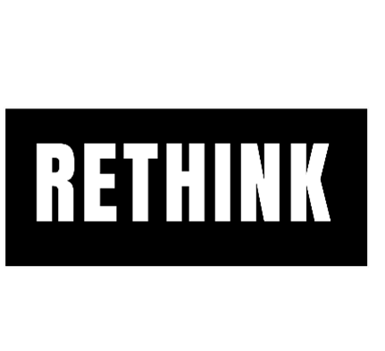
Rethink: Everyone in the funding sector must move away from the culture of internal, isolated, and top-down decision-making to collaborative approaches with the grassroots community. This is a move from charity to justice; It requires funders to see themselves not as decision-makers but as partners redistributing power to communities and investing in dismantling systemic oppression.


Why: By centring the expertise of those most affected, funders challenge the power imbalances that have long dictated who set the agenda and ensure that funding truly addresses systemic inequities. Redistributing power in this way ensures that funding addresses the root causes of inequity rather than maintaining the status quo of service provision.

Organisational Planning
Model funding organisations…
- Strategic Priorities
  - Are co-producing all strategic priorities with grassroots DPOs to address systemic oppression.
  - Coproduction sessions always include diverse Led By-And-For groups, especially those at the intersection of multiple marginalisations.
  - Are shifting priorities and their internal culture from service-based to systemic change-focused funding.
- Organisational Commitments
  - Are divesting from non-Led By-And-For organisations and have widely publicised this divestment to hold themselves accountable.
  - Equitably distribute power through participatory grant-making and community advisory panels.
  - Are reforming trustee boards and senior leadership teams to include structurally discriminated groups and ensuring that intersectional experiences are centred.
  - Release transparent and accessible funding criteria/decisions for community feedback.
  - Are also setting up feedback processes and ensuring it’s accessible by consulting with DPOs.
- Long-Term Vision
  - Are committed to distributing 10-year grants by 2030.
  - Provide a 2–5-year funding calendar for grantee preparation.
- Community Infrastructure
  - Only collect necessary evaluation material
    - Never ask groups to submit photographs of the people they work with in the name of impact assessment.
  - Are co-designing data banks for community use and analysis.
  - Promote grantee work to stakeholders in their network (e.g. policymakers, other funders)
  - Fund and support capacity-building programs, including strategic planning.

Tip from the experts: Don’t underestimate this step.
Co-producing only the grant or application process without addressing strategic priorities, organisational commitments or vision for the future risks perpetuating the same systemic inequities that marginalised groups face. By restructuring priority setting, funders ensure their entire approach is grounded in the lived realities of Led By-And-For organisations, creating alignment between community needs and the resources allocated.
While it might be tempting, skipping this step maintains top-down decision-making and misses the opportunity to dismantle systemic barriers at the root, leaving the funding ecosystem fundamentally unchanged.

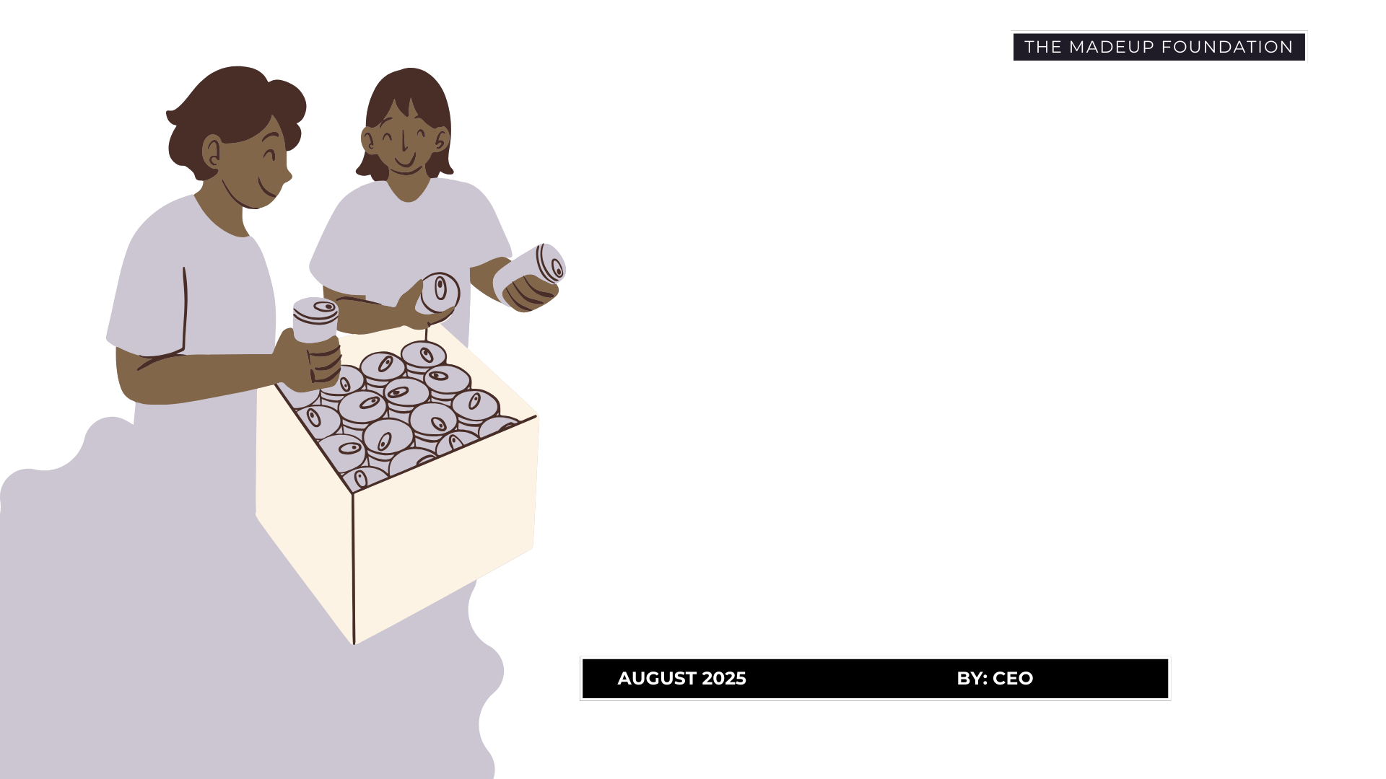

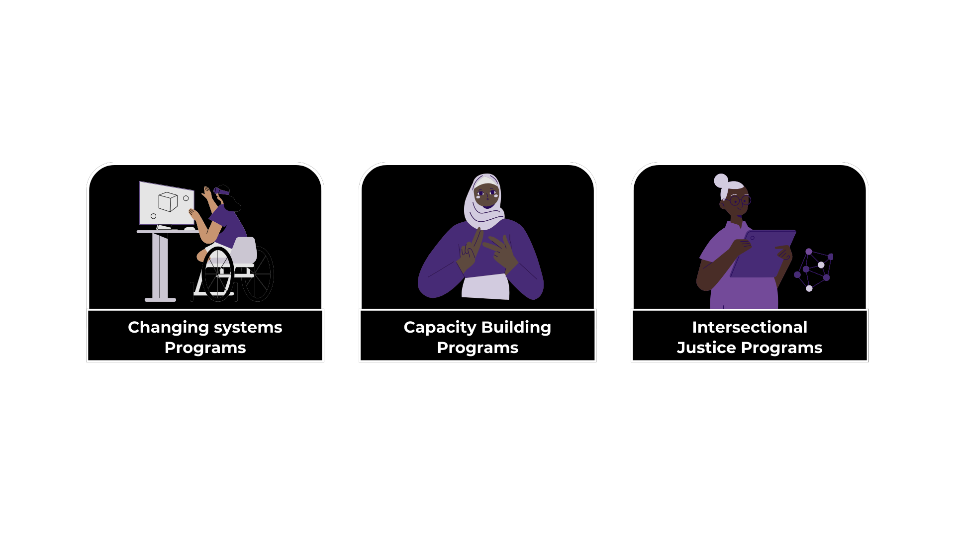

Designing the Fund
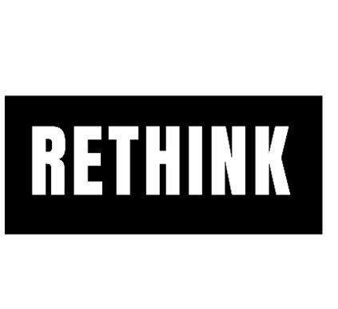
Rethink: Funders must relinquish control over rigid criteria and design for the community rather than for institutional convenience. Designing funds should be a co-produced process led by communities, with a commitment to accessibility, flexibility, and justice.

Why: This cultural shift decentralises power, allowing communities to shape funds that work for them rather than forcing them to fit into predefined structures.

Core Principles
Model Funding Programmes have….
- A Long-Term Focus: At a minimum, 5-year grants with the aspiration for 10-year terms.
- A Core and Flexible Basis: Core funding, which understands the general operational costs of Led By-And-For Disabled Peoples Organisations and includes budget/timelines for strategic planning outcomes.
- Equity for those most impacted: Dedicated funding pots for Intersectional, BSL-Led, D/deaf-Led, D/deafblind-Led, and other intersectional groups.
- Access Support: From application through to evaluation, provide:
  - Easy-read materials.
  - British Sign Language (BSL) interpretation.
  - Budget provisions for access needs.
- A Justice Lens: Eliminate systemic barriers in funding and prioritise structurally oppressed groups.

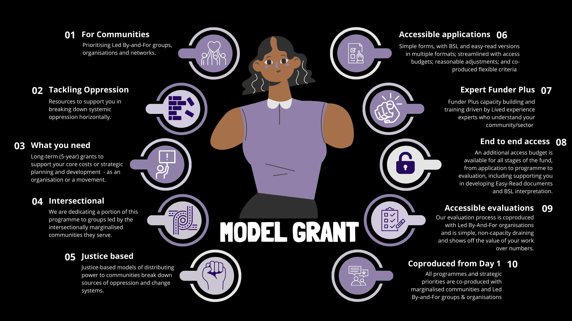

Example Fund Structures
Mode Dedicated Funding Programmes are….
- DPO Grants
  - Long-term (5–10 years), unrestricted core funding.
  - Prioritise intersectional and underrepresented disabled people.
  - Co-production of grant design with DPOs.
  - Flexible funding models based on unique organisational needs.
- Intersectional Grants
  - Long-term (5–10 years), unrestricted core funding.
  - Singular funds dedicated to intersectional Led By-And-For organisations.
  - Co-production of grant design with diverse collectives of intersectional Led By-And-For organisations.
  - Flexible funding models based on unique organisational needs.
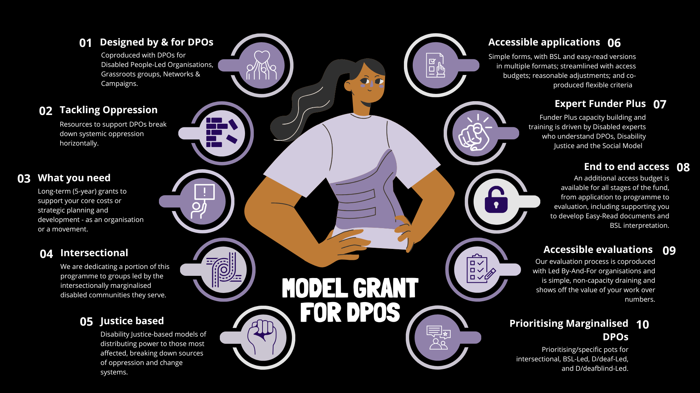

Grant Administration
Rethink: Funders must stop seeing applications as a gatekeeping tool and instead view them as an opportunity to reduce barriers and build trust with applicants. We must collectively move from a closed, hierarchical decision-making model to participatory grant-making, where communities have direct power over funding decisions.
Why: Simplifying the process and giving decision-making power back to the community redistributes power by ensuring that marginalised groups are equitably centred. Ultimately it challenges the paternalistic structures of traditional philanthropy and builds trust through accountability.

Applications
Model Applications Structures have:
- Accessible Process
  - Budgets for access support, including Easy-Read and BSL.
  - Flexible submission options (video, audio, written, Easy-Read).
  - Simple, co-produced forms.
  - Scope for reasonable adjustments.
- Transparent Criteria
  - Widely published clear, easy-to-understand criteria.
  - Require minimum information and only information the funding organisation doesn’t already have or cannot easily access (e.g., charity registration details already available).
  - Options for applicants to provide iterative feedback.
- Accountability to Communities
  - A requirement for applicants to evidence their internal representation of the communities they serve:
    - 75% of trustee boards are from the community they serve.
    - 51% of staff/volunteers from the community they serve.
  - A commitment to the Social Model of Disability and Disability Justice principles.

Grant Management
Model Grants Provide:
- Funder Plus Support
  - Expert Capacity-building programs delivered by Lived Experience experts.
  - Resources tailored to Led By-and-For organisation's unique challenges and goals.
- Horizontal Power Structures
  - Regular out-reach conversations with communities, grantee or otherwise, centred around building trust with grassroots groups.
  - Equitable decision-making power in program design and adjustments.
- Outcome Flexibility
  - Scope to conduce strategic planning, capacity development, and community empowerment.
  - Community-defined success metrics.



Evaluation and Monitoring

Rethink: Evaluation should focus on accountability to the communities served that reflect the realities of grassroots work, rather than funder-driven metrics. It must be co-produced and shaped by the values and outcomes defined by grantees themselves.
Why: Traditional evaluation metrics often fail to capture the nuanced, long-term impact of justice-oriented work and impose additional burdens on marginalised groups.

Evaluation processes
Model Evaluation processes have:
- Co-Produced Evaluation Metrics
  - Frameworks coproduced with grantees to ensure relevance and justice alignment.
  - Option for narrative-based and qualitative reporting.
- Accessible Reporting
  - Easy-Read, BSL, and other necessary support for reporting processes.
  - Already eliminated unnecessary bureaucratic barriers.
- Systemic Impact
  - A focus on dismantling systemic oppression.
  - Frameworks for celebrating and reporting on internal structure progress for equity and justice.

Transformative Organisational Practices
Rethink: Funders must reimagine their role as allies in dismantling systemic oppression by transforming their internal cultures to reflect justice, equity, and inclusion. This includes diversifying leadership, addressing systemic biases, and divesting from harmful partnerships.

Why: Without an internal cultural shift, funders cannot credibly redistribute power or act as true partners to the communities they aim to support.

Commitments:
Model Organisations commit to:
- Internal Commitments:
  - Representative Decision-Making Leadership: Restructuring board and leadership to reflect marginalised communities and creating grassroots advisory panels.
  - Staff Training: Providing staff training in Disability Justice, Intersectionality, the Social Model of Disability, and the DPO sector.
  - Internal Evaluation: Identifying and dismantling disablism, racism, sexism, and other systemic biases within our organisation.
  - Transparency: Ensuring full transparency in funding decisions, accessible formats for community feedback, and public criteria.
  - Ethical Partnerships: Divesting from harmful partnerships, including medical and charitable organisations that don’t align with our values.
- External Commitments:
  - Long-Term Grants: Distributing ten-year grants to Led By-And-For organisations by 2030, shifting focus to systemic change.
  - Amplifying Grantees: Supporting grantees in promoting their work to key stakeholders.
- Community Accountability
  - Establishing participatory governance models with grantee representation.
- Divestment from Harm
  - End partnerships with medical-model-based and non-Led By-And-For organisations.
  - Commit resources to Led By-And-For groups exclusively.





Questions for grant-making trusts/ funders to consider.
- How many DPOs versus disability charities led by non-Disabled people does your organisation fund?

Can you answer these questions?
  - Does the organisation you fund’s board have at least 75% Disabled and D/deaf trustees? Yes / No
  - Does their workforce consist of at least 51% Disabled and D/deaf employees? Yes / No
  - Are at least 51% of their volunteering team Disabled and D/deaf? Yes / No
  - Does the organisation have user involvement forums? Yes / No

- When did you last look at the power distribution in your organisation?

For example:
- What percentage of your Board of Trustees and senior leadership identify as Disabled and D/deaf?
- What economic communities do your Board of Trustees come from?
- How many of your Board of Trustees have intersecting marginalised identities? Some examples: Disabled, Racialised and ethnically minoritised, LGBTQIA 2S+, gender marginalised, migrant and refugee, working class, Roma and traveller.

- Have your staff team and board received Disability Equity or Disability Justice training?

- Do you involve Disabled and D/deaf people in your decision-making process concerning what social issues require funding from the design phase of the programme?

- How do you include disability in all your social justice/equality work?

- Will you join a national group of funders to co-produce a funding justice plan with us?

What next?
We believe in the power of coproduction and know that changing the funding landscape cannot be done alone. We want to coproduce a strategy for change with you!

If you would like to join us on our journey, please contact us. Details can be found on our campaign page: https://www.disabilityrightsuk.org/funding-justice.

Disability Justice: A framework and movement that goes beyond the traditional civil rights-based approach to disability. It recognises the intersecting identities and experiences of D/deaf and Disabled people and focuses on collective liberation, interdependence, and the dismantling of all forms of systemic oppression (Sans Invalid, 2019).
Disabled Peoples Organisations: An umbrella term for an organisation or group where Disabled people represent at least 75% of the board and 50% of staff and volunteers. DPOs actively demonstrate a commitment to the Social Model of Disability through its work, values and operations. Under the umbrella of DPO are D/deaf and Disabled People’s Organisations (DDPOs), User-led Organisations (ULOs), Disabled-People Led Groups and Intersectional DPOs. An in-depth description of DPOs and By and For Organisations can be found in our Analysis ‘We, Disabled People’.
Intersectional Led By-And-For groups: A community organisation governed and operated by people from the intersectionally marginalised communities it serves (e.g., Deaf migrants

