Statement on publication of the Grenfell Tower Inquiry Phase 2 Report
This Statement is made in response to the final Grenfell Tower Inquiry Report published on 4 September 2024. It sets out the actions that the new UK Government should take to protect Disabled residents from fire and to create a housing stock that truly meets our needs.
As organisations and professionals representing Disabled people, we pay tribute to Grenfell survivors and bereaved families for their tireless struggle for justice. We mourn the deaths of all those who avoidably died in the Grenfell Tower fire. We acknowledge the disproportionate deaths of Disabled residents.
The appalling actions perpetrated by central and local government, building owners and managers and private construction companies, failed to uphold the values of equity decency and respect, putting profit before people. Racism and disablism were strong contributors to the events that led to the fire, including the many ways in which the views and complaints of residents were devalued, disregarded and ignored.
We welcome the commitment of the new UK Government to ensure that such an event never happens again.
In pursuit of this aim, we ask that the following actions are taken.
Implement the Personal Emergency Evacuation Plans (PEEPs) recommendation
We call on the Government to take immediate steps to amend the Fire Safety (England) Regulations 2022 to impose a clear and specific duty on responsible persons (owners or managers) to prepare a PEEP for anyone who needs support, assistance or aids in order to evacuate to a place of safety in case of fire. Responsible persons must use best endeavours to ensure that PEEPs are drawn up for anyone who needs them, including surveying their residents to ensure that no one is excluded.
Since 2005, the ‘responsible person’ for a residential block under the Fire Safety Order (the owner and/or manager) has had a duty to ensure that Disabled people can evacuate blocks of flats as quickly and safely as possible.
The Phase 2 Report explains that “In the Phase 1 report [published on 30 October 2019], the Chairman recommended that the owner and manager of every high-rise residential building be required by law to prepare personal emergency evacuation plans (PEEPs) for all residents whose ability to escape may be compromised, such as persons with reduced mobility or cognition. Disabled people were particularly affected by the speed and ferocity of the Grenfell Tower fire.” (14.2)
The widescale disregard of existing duties which led to that recommendation is laid bare in GTI’s Phase 2 Report. It found that “the TMO [Tenant Management Organisation] at the highest level was aware from as early as 2009 of the need to consider the arrangements for the safe evacuation of disabled people and, … RBKC [Royal Borough of Kensington and Chelsea] was itself fully aware of the fact”. (46.23)
Despite misleading representations to the London Fire Brigade (LFB) that the PEEPs duty was being complied with, neither RBKC nor the TMO took any effective steps to draw up PEEPs to enable Disabled residents to evacuate in case of fire.
The Report found that “RBKC and the TMO were jointly responsible for the management of fire safety at Grenfell Tower. The years between 2009 and 2017 were marked by a persistent indifference to fire safety, particularly the safety of vulnerable people.” (2.58) It concluded that “On any view, the Grenfell Tower fire revealed the importance of ensuring that the responsible person collects sufficient information about any vulnerable occupants to enable PEEPs to be prepared, when appropriate, and, in the event of a fire, appropriate measures to be taken to assist their escape. The TMO’s failure to collect such information illustrates a basic neglect of its obligations in relation to fire safety”. (46.90)
We welcome the Prime Minister’s commitment, in his statement responding to publication of the Phase 2 report, that the Government would now address the Phase 1 recommendation on PEEPs (House of Commons, 4 September 2024). Such a clear commitment is a welcome contrast to the previous governments that have unforgivably and repeatedly avoided implementing the GTI’s PEEPs recommendation for almost five years since it was issued.
While we welcome any further proposals by government departments to expand on measures to enhance the safety of Disabled residents, these should not delay the immediate implementation of the measure set out above in the first paragraph of this section.
The Building Safety Regulator already provides guidance on how to survey residents to identify those who are Disabled or vulnerable, including inclusive measures to meet duties imposed by the Equality Act 2010. There can be no excuse for failing to do so, or arguing that it is too hard.
As GTI’s Report shows, close to half (43.25%) of Disabled adults present in Grenfell Tower on the night of the fire were killed. None of them had been provided with a PEEP. By the time the TMO supplied its inadequate list of vulnerable residents to the LFB, they were all dead. Only by imposing this duty into regulations in black and white, without delay, will the Government meet the urgency and seriousness of the situation where the PM said that Disabled people “are housed in circumstances in which they clearly need an evacuation plan” (House of Commons, 4 September 2024).
Every Disabled individual that needs support to evacuate a residential building should be able to coproduce their PEEP. They must be consulted on all elements. However, the responsible person must not try to avoid their duty to enable safe evacuation from their building by shifting the burden of evacuation planning onto the shoulders of the Disabled resident.
Nor may they avoid the duty to have an evacuation plan by relying on the Fire and Rescue Service (FRS) to rescue these residents from burning blocks. The consequences of expecting disabled people to await FRS were illustrated by the evidence in the GTI of Mariko Toyoshima-Lewis, a resident of the Tower and wheelchair user. On the night of the fire, she told her family to go without her. She remained, thinking she would die, until being dragged downstairs by fire fighters in a last minute, terrifying, and painful rescue. That was not some aberration. That disabled people should be left behind to hope for FRS rescue was what the last government expressly advocated in its rejection of the Phase 1 PEEPs recommendation. Disabled residents must be entitled to equal treatment, including the right to evacuate alongside nondisabled residents and not be left behind.
Any proposals must be developed in collaboration with Disabled people
Disabled People’s Organisations (DPOs) should be involved in developing any further proposals relating to the safety of disabled residents from the outset and not merely after they have already been developed and published for consultation.
The Report lays bare the results of the failure to consult Disabled people in the creation of guidance affecting their fire safety over the decade before the Fire.
In the wake of the Lakanal House fire, the Government (the DCLG then being the responsible department) engaged a predecessor of the LGA to draft ‘guidance’ to landlords and responsible persons on fire safety in blocks of flats. The work was delegated to C S Todd and Associates.
In light of how Disabled people were “particularly affected” by the fire, the GTI explained that “we explored why the LGA Guide advised landlords and responsible persons that it was usually unrealistic to plan for the evacuation and assistance in the event of a fire of disabled and vulnerable residents living in … blocks of flats such as Grenfell Tower.” (14.2)
Although the guidance was developed under the auspices of the Government, no DPO or disability specialist was invited to take part in the project group. There was “a detailed and wide-ranging consultation” yet “neither the department nor C S Todd and Associates took any steps to ensure that the views of organisations representing the disabled and the vulnerable were sought”. Even when “the Chief Fire Officers Association said that not to include advice on the evacuation of disabled people was a fundamental error”, the GTI could not determine “whether that particular question was discussed” and “In any event, a disability specialist or someone who could represent those who were disabled and vulnerable was not appointed to assist”. The response of the Chief Fire Officers “was either considered and rejected or simply ignored”. (14.5-6) The lack of consideration of the position of disabled residents made it impossible even to tell which applied.
Following publication, Elspeth Grant, a fire safety and disability specialist, wrote that the guidance that landlords need not have a plan for the evacuation of disabled residents “encouraged readers to ignore the Fire Safety Order and to breach international and domestic law on equality and fire safety and to breach international and domestic law on fire safety [and] reflected an outdated viewpoint, and was discriminatory”. (14.8) The Government sought no advice on whether this “allegation of unlawful discrimination was well-founded or not”. The Report finds that “The response of the department to Ms Grant’s letter was wholly unsatisfactory; it was, in effect, simply brushed aside.” (14.10)
Subsequent guidance (BS 9991) was published emphasising the need to “pay particular attention to the needs of disabled people” and that “many people living in standard accommodation have a range of impairments that could affect their ability to evacuate”. The Report finds that “it is surprising and disappointing … that the department failed to recognise” the “very different approach” compared to the LGA Guide, and the failure to reconcile the two was “a significant oversight” by the Government. (14.12-3)
The Government then received a draft internal report on the published guidance expressing concerns, similar to those that it had already brushed aside, about “a failure of the government to understand that disabled people could not escape from flats without help in the event of a fire and that more guidance was needed on the provision of PEEPs for residents known to have difficulty escaping or to be unable to escape … blocks of flats without assistance”. The Report found that the Government “considered it too difficult to find a solution to the problem posed by vulnerable persons who could not escape from purpose-built general needs blocks of flats without assistance” (14.14-5)
The way that the rights and risks to life of disabled people were “brushed aside” by the Government and viewed as “too difficult” reflects a culture of indifference in the years leading up to the fire which was enabled by the consistent failure to involve DPOs and Disabled people and specialists.
By committing to collaborating with Disabled people on all further proposals, the Government can stand against the neglect, indifference, and discrimination of the past.
Extend the definition of higher-risk buildings
GTI recommended that “the definition of a higher-risk building for the purposes of the Building Safety Act be reviewed urgently” (emphasis added). It concluded that it was unsatisfactory “to define a building as “higher-risk” by reference only to its height” which was “essentially arbitrary in nature” because “more relevant is the nature of its use and, in particular, the likely presence of vulnerable people, for whom evacuation in the event of a fire or other emergency would be likely to present difficulty”. (113.7)
The Government must act immediately on what the GTI emphasised was an “urgent” recommendation.
We call on the Government to extend the PEEPs requirement to all residential blocks housing disabled residents to which the Fire Safety Order applies.
Acknowledge Disabled people in legislation and guidance on fire safety strategy
The Report states that “One thing that has emerged clearly from our investigations is that in order to ensure the safety of occupants, including any with physical or mental impairments, those who design high-rise buildings need to be aware of the relationship between the rate at which fire is likely to spread through the external walls and the time required to evacuate the building or the relevant parts of it”. It concludes that “Calculating the likely rate of fire spread and the time required for evacuation, including the evacuation of those with physical or mental impairments, are matters for a qualified fire engineer” and recommends that “a calculation of that kind … ought to form an essential part of any fire safety strategy”. (113.13)
It further recommends that “it be made a statutory requirement that a fire safety strategy produced by a registered fire engineer to be submitted with building control applications [which] must take into account the needs of vulnerable people, including the additional time they may require to leave the building or reach a place of safety within it and any additional facilities necessary to ensure their safety.” (113.15)
These recommendations foreground the risks to Disabled people for building design and fire safety strategy. The Government must implement them.
Make housing accessible
All residential buildings should be made as accessible as possible, including giving effect to the anticipatory duty in the Equality Act. This should apply to all features of a building including the size of lifts and number of evacuation lifts, the installation of ramps, the availability of good lighting and the fitting of stair rails. All new build, whether residential blocks or single houses, should be built to M4(2) with 10% built to wheelchair accessible standards M4(3). These requirements should be clearly set out in law.
Engage with Disabled residents
Building on the duties in the Building Safety Act 2022, Disabled people living in residential blocks should be regularly consulted on issues affecting the safety and repair of the building. Engagement should be fully accessible to all residents and meet the needs of people with different impairments or health conditions. This includes providing accessible information and communication. The communication needs of Disabled people facing other forms of oppression, such as those based on language, ethnicity, sexual orientation or age, should also be addressed.

Support during Remediation
Disabled people should receive wrap around support when buildings are being remediated, whether for the removal of cladding or the making of other improvements. This means the building owner and manager working with social care services, housing services and private building contractors, to ensure that Disabled residents are supported throughout this disruptive and distressing process. This should be set out in law.
Conclusion
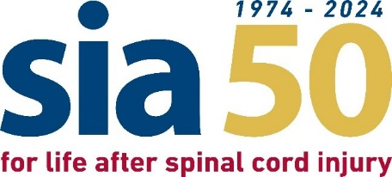
We the undersigned are willing and ready to work with the UK Government to affect a sea change in housing law and policy to bring about equity of experience for Disabled residents.
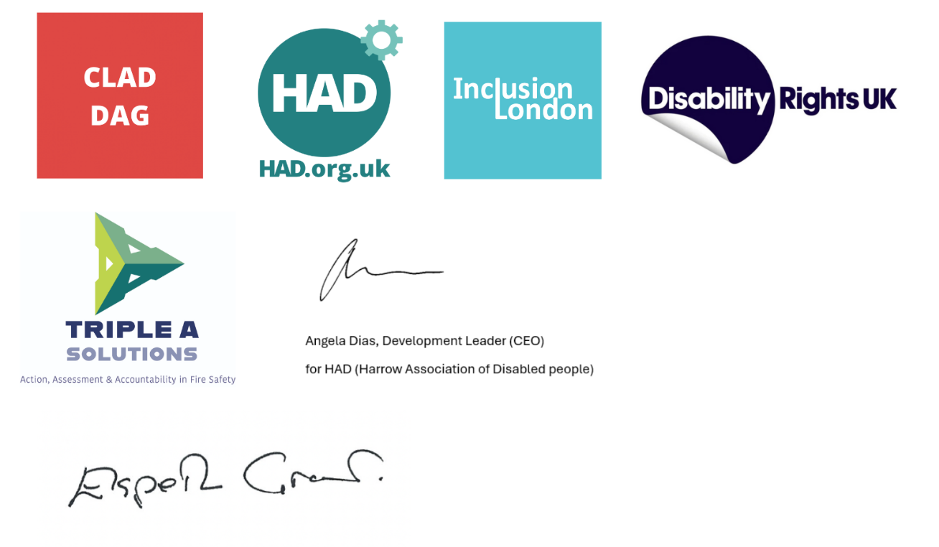

Regulatory Reform (Fire Safety) Order 2005
References are to the Phase 2 Report unless otherwise stated.

