
Come and help us improve care for everyone

  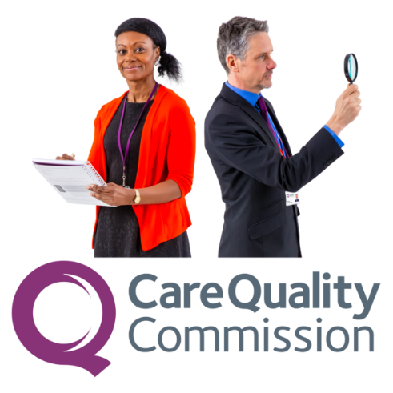 | We are the Care Quality Commission. Our inspectors check health services, like hospitals, social care services and care homes, to make sure they give good care to people.  We want people to tell us about their experiences of health and social care.
 | This helps us to understand what is working and what could be improved to make care better for everyone.

What we are looking for

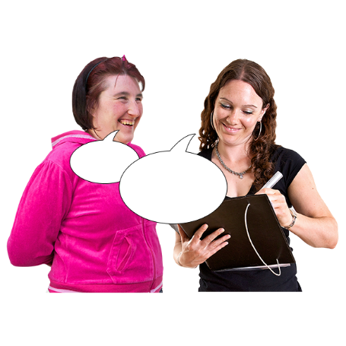
We would like to hear from people with a learning disability and autistic people for a new piece of work.
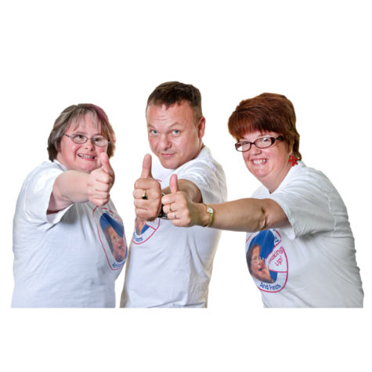

We are looking for ambassadors.


Ambassadors speak up for a group of people.

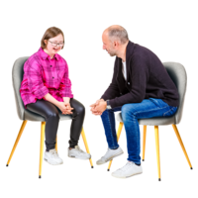
We are looking for people who are happy to share stories about the care they have received.


We also want these people to encourage other people to give feedback to us.


We want to hear from you if you have a story about a good service, like support from staff who made you feel safe and comfortable.


We would also like to hear from you if you have a story about a bad service, like not feeling respected or safe in hospital or care.

Being an ambassador


If you are chosen to be an ambassador, we will work with you to make sure you can tell your story in your own way.


You would have your photograph taken by a photographer who also has a learning disability or who is autistic. Photo shoots will take place in March.

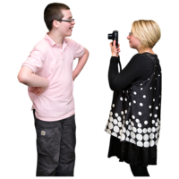
We want the photographs to show your own experience of health and social care.


The photographs will be used to encourage other people to share feedback on their care. We will put them on social media (like Twitter) and on our website.


The photos might also be used by newspapers and other websites who write about this piece of work.


If you become an ambassador, we would be happy for you to share the photographs on your own social media accounts or websites.


We are also very happy for your family or carers to support you.


We will pay for you to travel to the photo shoot and will pay for all journeys you make as part of your role as an ambassador.

Get in touch


If you have a learning disability or if you are autistic and you would be interested in becoming an ambassador, or have any questions, please email Jay Harman from CQC: jay.harman@cqc.org.uk by Monday 20th March 2023.


In your email, please put your name, your age, where you live and your story of health and social care that you would like to share.

